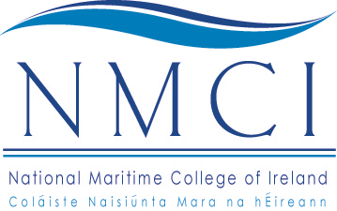

NATIONAL MARITIME COLLEGE OF IRELAND
Coláiste Naisiúnta Mara na hÉireann
(a constituent college of Cork Institute of Technology in partnership with the Irish Naval Service and Focus Education)

APPLICATION FORM FOR ADMISSION TO THE
Higher Certificate in Science in Nautical Studies/Certificate in Seamanship

PART 1 – PERSONAL DETAILS

Surname: ________________________________ First Names: __________________________________
(as per Birth Certificate)

Title: ________________ Date of Birth: ___________________ Nationality: ______________________
(Mr/Mrs/Miss etc.)

Address: _____________________________________________________________________________

_____________________________________________________________________________

_____________________________________________________________________________

Home Telephone No.: _____________________ Mobile No.: ___________________________________

E-mail Address: ____________________________________________________________________________

Address for Correspondence (if different from above):

_____________________________________________________________________________

_____________________________________________________________________________

Please detail here any other information, which may be helpful to your application. Give full details of all relevant work experience obtained, particularly the duration and nature of the work. Additional information may be supplied on a separate sheet if necessary.

_________________________________________________________________________________________

_________________________________________________________________________________________

_________________________________________________________________________________________

_________________________________________________________________________________________

_________________________________________________________________________________________

_________________________________________________________________________________________

(See Overleaf)

PART 2 – EDUCATION DETAILS

EDUCATIONAL RECORD:
Second Level Schools Attended

Name of School(s) | Address | Years  From: To:

EXAMINATIONS TAKEN:

Junior Certificate or Equivalent

Subject | Year | Grade | Result | Subject | Year | Grade | Result

Leaving Certificate

Subject | Year | Grade | Result | Subject | Year | Grade | Result

I declare that the information given by me on this Application Form is true and accurate.

Signed: ____________________________________________________ Date: ______________________________

This form, fully completed should be returned to the
CIT Administration Office, National Maritime College of Ireland,
Ringaskiddy, Co Cork on or before FRIDAY, 9 AUGUST 2013.

This application form does not infer or impose any legal obligations on Cork Institute of Technology to provide courses or other services to students. It does not constitute an offer to supply any course and it is not to be construed as imposing a legal obligation on the Institute to supply courses or subjects in respect of any course of study.

Data Protection Act: Information held by the Institute on computer will be used only for the purposes registered under the Data Protection Act 1988, that is the provision of education and training services. A copy of your details held by the Institute on computer is available on request. A fee may be payable for this.

